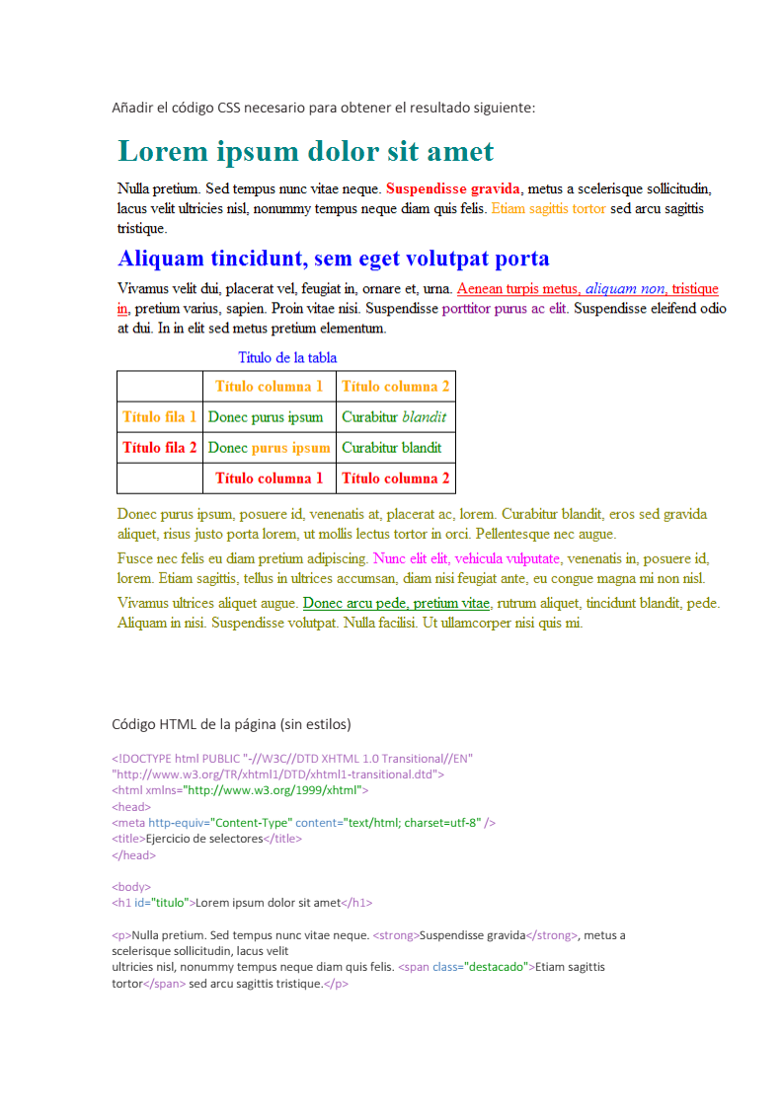

<!DOCTYPE html PUBLIC "-//W3C//DTD XHTML 1.0 Transitional//EN" "http://www.w3.org/TR/xhtml1/DTD/xhtml1-transitional.dtd">
<html xmlns="http://www.w3.org/1999/xhtml">
<head>
<meta http-equiv="Content-Type" content="text/html; charset=utf-8" />
<title>Ejercicio de selectores</title>
<style type="text/css">
table, tr, th, td {border:1px solid #000; border-collapse:collapse; padding:5px;}
h1#titulo { color: #07BB4D; }
h2#subtitulo { color: blue; }
div#adicional p { color: #3FBF12; }
div#adicional span#especial { color: #F00DE4; }
div#adicional a { color: green; }
strong { color: red; }
span.destacado { color: orange; }
span.especial { color: purple; }
a { color: red; }
a em { color: blue; }
caption { color: blue; }
td { color: green; }
td strong { color: orange; }
th { color: red; }
th.especial { color: orange; }
</style>
</head>

<body>
<h1 id="titulo">Lorem ipsum dolor sit amet</h1>

<p>Nulla pretium. Sed tempus nunc vitae neque. <strong>Suspendisse gravida</strong>, metus a scelerisque sollicitudin, lacus velit
ultricies nisl, nonummy tempus neque diam quis felis. <span class="destacado">Etiam sagittis tortor</span> sed arcu sagittis tristique.</p>

<h2 id="subtitulo">Aliquam tincidunt, sem eget volutpat porta</h2>

<p>Vivamus velit dui, placerat vel, feugiat in, ornare et, urna. <a href="#">Aenean turpis metus, <em>aliquam non</em>, tristique in</a>, pretium varius, sapien. Proin vitae nisi. Suspendisse <span class="especial">porttitor purus ac elit</span>. Suspendisse eleifend odio at dui. In in elit sed metus pretium elementum.</p>

<table summary="Descripción de la tabla y su contenido">
<caption>Título de la tabla</caption>
<thead>
<tr>
<th scope="col"></th>
<th scope="col" class="especial">Título columna 1</th>
<th scope="col" class="especial">Título columna 2</th>
</tr>
</thead>

<tfoot>
<tr>
<th scope="col"></th>
<th scope="col">Título columna 1</th>
<th scope="col">Título columna 2</th>
</tr>
</tfoot>

<tbody>
<tr>
<th scope="row" class="especial">Título fila 1</th>
<td>Donec purus ipsum</td>
<td>Curabitur <em>blandit</em></td>
</tr>
<tr>
<th scope="row">Título fila 2</th>
<td>Donec <strong>purus ipsum</strong></td>
<td>Curabitur blandit</td>
</tr>
</tbody>
</table>

<div id="adicional">
<p>Donec purus ipsum, posuere id, venenatis at, <span>placerat ac, lorem</span>. Curabitur blandit, eros sed gravida aliquet, risus justo
porta lorem, ut mollis lectus tortor in orci. Pellentesque nec augue.</p>

<p>Fusce nec felis eu diam pretium adipiscing. <span id="especial">Nunc elit elit, vehicula vulputate</span>, venenatis in,
posuere id, lorem. Etiam sagittis, tellus in ultrices accumsan, diam nisi feugiat ante, eu congue magna mi non nisl.</p>

<p>Vivamus ultrices aliquet augue. <a href="#">Donec arcu pede, pretium vitae</a>, rutrum aliquet, tincidunt blandit, pede.
Aliquam in nisi. Suspendisse volutpat. Nulla facilisi. Ut ullamcorper nisi quis mi.</p>
</div>

</body>
</html>

